Print
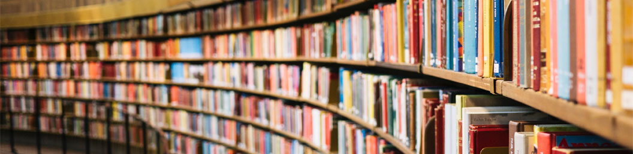

TOP DOWNLOADED PAPER 2018-2019
CONGRATULATIONS TO
Branko STANOVNIK
whose paper has been recognized as
one of the most read in
European Journal of Organic Chemistry

