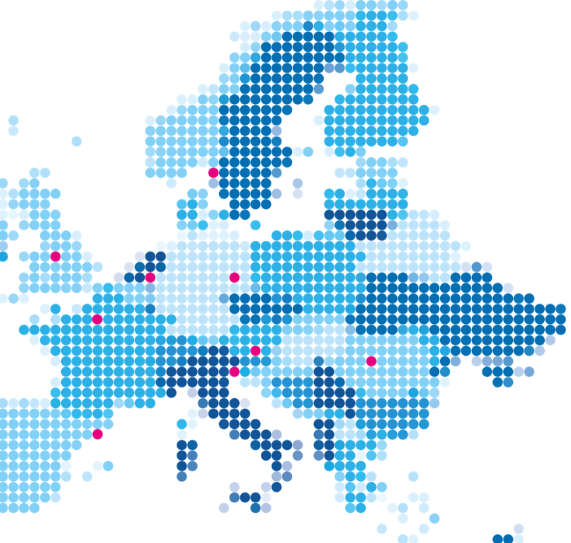

Motivational letter

  - Training programme on EU funding

Motivational letter
Please think about a potential research proposal idea and send us a document (PDF format) of maximum 2 pages containing the following information:
What are the objectives of your research proposal? What do you aim to achieve?
Which methods will be needed to achieve these objectives?
What are the innovative aspects of your proposal? And what is its societal, scientific, economic, and/or technological impact?
Please explain your motivation to apply for this training programme in maximum 150 words (not included in the 2-pager).

