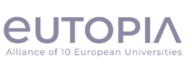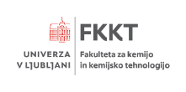

‘From Local to Global: A Future for the Environment’
EUTOPIA Global Connections PROJECT
(12. February -11. March 2024)

Are you interested in the future of our Environment?
Come collaborate with us on a small, cross-university project with students from universities throughout Europe on this important theme. The EUTOPIA Learning Community, ‘Global Connections’ will be hosting another learning opportunity for students interested in building working relationships across borders; engaging in intercultural discussions on environmental issues; and becoming part of a multidisciplinary research team. Together, you will critically explore how nations/regions of the world tackle contemporary environmental issues, and investigate the extent to which these strategies ‘translate’ across borders and academic disciplines.

The project will be run online using MS Teams, based on individual work of groups. The project will be in English. You will have four weeks to create an artefact together in the format of your choice, based on your research. Your participation will result in an international certificate issued by EUTOPIA. Students of all disciplines and levels of study are welcomed.

The coordinator and mentor of this project at UL is prof. dr. Andreja Žgajnar Gotvajn (UL FKKT).

Please send your expression of interest (Registration form, Consent form), and any questions about this opportunity to Melina.Delmas@warwick.ac.uk and dr. Ula Rozman (ula.rozman@fkkt.uni-lj.si) by Monday, 5. February 2024.

Looking forward to seeing you there!

Link:
- Registration form
- Consent form
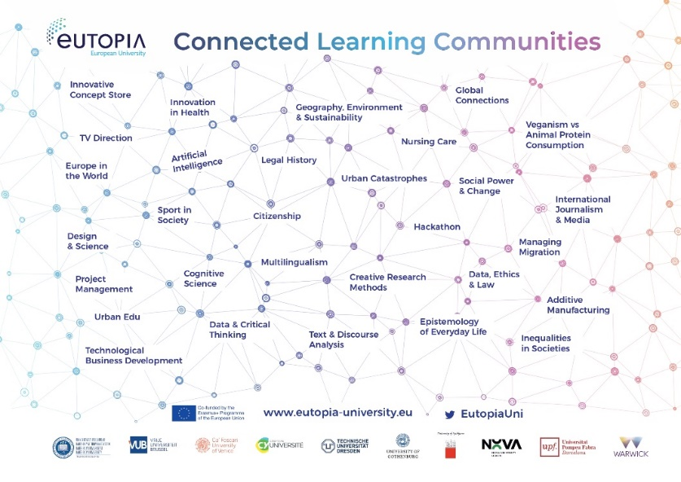

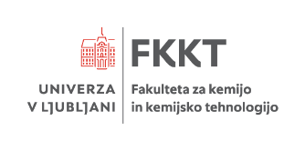

`From Local to Global: A Future for the Environment’
EUTOPIA Global Connections PROJECT
(12. February -11. March 2024)

Vas zanima prihodnost našega okolja?
Pridite in sodelujte z nami pri meduniverzitetnem projektu s študenti z univerz iz cele Evrope. Učna skupnost EUTOPIA (The EUTOPIA Learning Community, ‘Global Connections’) bo ponovno organizirala učno priložnost za študente, ki jih zanima vzpostavljanje mednarodnih povezav, vključevanje v medkulturne razprave o okoljskih vprašanjih in ki želijo postati del multidisciplinarne raziskovalne skupine. Skupaj boste kritično raziskovali kako se države oziroma regije po svetu spopadajo s sodobnimi okoljskimi vprašanji in raziskali, v kolikšni meri se te strategije prenašajo preko državnih mej in akademskih disciplin.

Projekt bo potekal on-line preko MS Teams aplikacije, na podlagi individualnega dela skupin, v angleškem jeziku. Imeli boste 4 tedne, da skupaj na podlagi svojih raziskav določene tematike ustvarite izdelek v formatu po vaši izbiri (poster, spletna stran, video, itd.). Sodelujejo lahko študenti vseh študijskih smeri in letnikov, tudi doktorski študenti. Sodelujoči boste prejeli tudi mednarodni certifikat o sodelovanju, ki ga bo izdala zveza EUTOPIA.

Koordinator in mentor tega projekta na UL je prof. dr. Andreja Žgajnar Gotvajn (UL FKKT).

Prosimo, da pošljete svojoo prijavo (obrazec za registracijo, soglasje) na naslov Melina.Delmas@warwick.ac.uk in asist. dr. Uli Rozman na mail ula.rozman@fkkt.uni-lj.si do ponedeljka, 5. februarja 2024.

Veselimo se vaše udeležbe!

Povezava:
- Obrazec za registracijo
- Soglasje

