Sport and health, FKKT, UL Name and surname:_________________________

Write a general assessment of your lifestyle (diet, sleep, relaxation, physical activity, vices) in terms of the health recommendations you know. Use an emoji to mark your current feeling.

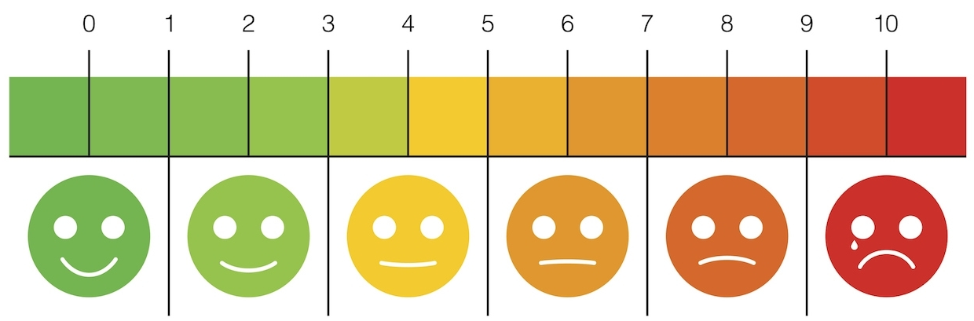

Write down the lifestyle change goals you would like to achieve in 4 weeks:
 | A goal that I will achieve in 4 weeks. | Intervention - what will you do for it in week 1? | Intervention - what will you do for it in week 2? | Intervention - what will you do for it in week 3? | Intervention - what will you do for it in week 4?
For me, the most important thing is:
Food and fluids:
Sleep:
Relaxation:
Physical activity
Sitting:
Vices/risky health behaviors/peculiarities:

By signing, I undertake to achieve the goals I have set for myself within 4 weeks: ______________________________
Write the data for the measurements:
Date of measurement | Resting heart rate  (in ft/min) | Body weight (in kg) | Waist circumference (in cm) | Hip circumference (in cm) | Abdominal circumference (in cm) | Mobility – sitting forward (in cm) | Movement quality – FMS squat (1-3) | Aerobic endurance –__________ (write the test) | Trunk strength –__________ (write the test) | Trunk strength –__________ (write the test) | Trunk strength –__________ (write the test)

Write a reflection / diary / observation related to the achievement of personal goals (what you did, changed, achieved...) in the past week. Show how you feel with an emoji.
Week 1 | Week 2 | Week 3 | Week 4

